AGENCY NAME HERE

AGENCY LOGO HERE

Cyber Incident Management and Response Plan

Created: 08.19.2022

CONFIDENTIAL

Overview
The AGENCY NAME HERE recognizes the importance of establishing a Cyber Incident Management and Response Plan (CIMRP) capable of timely actions and communications to ensure comprehensive and consistent responses to each Security Event and Cyber Incident.

This document outlines the actions and procedures required for the initial analysis, evidence collection, and classification of any reported Security Events. If any Security Event becomes classified as a “Cyber Incident,” this document further establishes the phases, action items, responsibilities, and documentation required for managing all Cyber Incidents in compliance with the State’s Information Security Policy.

Scope
This plan applies to all networks, devices, and services provided to students, faculty, guests, partners, colleges, departments, or divisions of AGENCY NAME HERE.

Approval
The Cyber Incident Management and Response Plan was reviewed, approved, and published on XXXX,XXXX 2022.

________________________________________
CISO NAME HERE,
Chief Information Security Officer (CISO)

________________________________________
CIO NAME HERE,
Chief Information Officer (CIO)

________________________________________
COO NAME HERE,
Chief Operational Officer (COO)

________________________________________
AGENCY PRESIDENT NAME HERE,
AGENCY NAME HERE President

Contents
Overview 2
Scope 2
Approval 2
Cyber Incident Management by Phase 5
Preparation 6
Cyber Steering Group (CSG) 7
Cyber Incident Response Manager (CIRM) 7
Information Collection Requirements 11
Security Event Reporting 12
Evidence Collection Process 14
Identification and Classification 15
Identification 15
Classification 16
Post-Classification Actions 17
Containment 18
Short-Term Containment 18
Root-Cause Analysis 19
Long-Term Containment 20
Eradication 21
Eradication is required when: 21
Recovery and Remediation 22
Short Term Recovery 22
Long Term Recovery 23
Recovering from Complete System Failure 23
Critical Post Recovery Actions and Monitoring 24
Lessons Learned 25
Minimum Topics of Discussion 25
Continuous Plan Evaluation 26
Training and Communication 26
Testing and Table-Top Exercises 26
Volunteers 26
Referenced or Supporting Documents 27
State Documents 27
Federal Documents 27
Contacts 28
CSG and CIRT Assignments 28
Federal and State 29
Third Parties and Partners 30
Incident Response Plan - Revision and Review Log 31
Emergency Support Function – 17 Personnel | Skillsets and Credentials 32
Figure 1 33
Figure 2 34
Figure 3 35
Louisiana State Police Cyber Crime Unit | Evidence Collection and Analysis Process 36
WebEOC Initiation Instructions and Process 37
GLOSSARY 42

Cyber Incident Management by Phase
The Plan
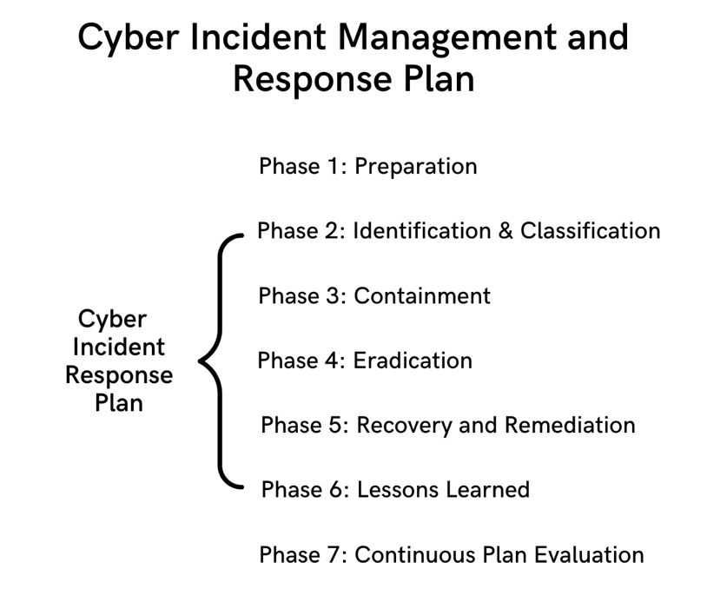
All Cyber Incidents are managed in accordance with a proven programmatic method that follows seven phases in chronological order, which incorporates a Cyber Incident Response Plan:
- Preparation
- Identification and Classification
- Containment
- Eradication
- Recovery and Remediation
- Lessons Learned
- Continuous Plan Evaluation

Phase 1

Preparation
A Cyber Incident Management and Response Plan requires minimum preparatory actions, absent which a Cyber Incident Response Plan cannot function.
Proper Preparation includes, but is not limited to, the following action items:
- The development, implementation, and on-going maintenance of a formal Cyber Incident Response Plan (CIRP).
- The creation and assignment of named individuals to a Cyber Steering Group (CSG).
- The designation of a Cyber Incident Response Manager (CIRM) to a named individual or entity.
- The creation and assignment of named individuals to a Cyber Incident Response Team (CIRT).
- Establish, document, and maintain Cyber Incident notification procedures.
- Establish, document, and maintain minimum information collection requirements.
- Procure required supplies, tools, technologies, and facilities required to support CIRT standard processes and timely actions.
- Ensure all servers, web applications, workstations, firewalls, and security platforms are implemented and maintained with configurations to produce the required system events and audit logs.
- Ensure alerts are systematically generated for all known critical and high severity threat events (network, server, or workstation) and sent to individuals or partners who are assigned the responsibility for active threat monitoring.
- Create and publish Policy and Procedures for Reporting Security Events to Students, Faculty, and Partners.
- Ensure critical AGENCY NAME HERE Services have scheduled backups produced daily and stored completely external to the AGENCY NAME HERE or service provider network.
Critical Note:
- System backups used for the Recovery and Remediation phase must be stored offline prior to a cyber incident or attack.

Cyber Steering Group (CSG)
CSG Core Responsibilities:
- Serve as executive decision-making authority for AGENCY NAME HERE’s Cyber Incident management and response activities and planning.
- Assigns the responsibility of Cyber Incident Response Manager to a named individual, entity, or organization.
- Serve as the sole approving authority for requested exceptions/deviations to any policy, plan, or procedure that affects this Cyber Incident Management and Response Plan.

CSG Core Members (pre-determined and unaffected by any Security Event or Cyber Incident):

- Chief Operations Officer (COO) (or as designated by the AGENCY NAME HERE President)
  - Considers and evaluates impact of Cyber Incident on current and future operations.
- Chief Information Officer (CIO)
  - Considers and implements mitigation controls, maintains, and reviews network maps, provides updates and guidance to senior leadership, plans recovery and remediation.
- Chief Legal Officer (likely to be separate from other counsel representing the AGENCY NAME HERE)
  - Provides guidance on impact to regulated data, maintaining confidentiality and privilege, reviewing vendor agreements for outside assistance, control third party communications, and evaluate AGENCY NAME HERE benefits.
- Public Relations Officer
  - Manages all external and internal communications according to procedures set forth herein.

Cyber Incident Response Manager (CIRM)

CIRM Responsibilities:
- Akin to CSG members, the CIRM is pre-determined and unaffected by any Security Event or Cyber Incident.
- Responsible for receiving authority from CSG to initiate (and initiating) WebEOC request through the Governor’s Office of Homeland Security and Emergency Preparedness (GOHSEP) to initiate assistance from Emergency Support Function -17 (ESF-17) following classification of a Security Event as a Cyber Incident.
  - WebEOC Initiation Instructions are here.
  - Responsible for coordinating ESF-17 assistance through Phases 3 and 4 following classification of a Security Event as a Cyber Incident.
- Creates, reviews, and finalizes of Cyber Incident Response Report (CIRR).
- Successful coordination and collection of minimum required information requirements.
- Assigns Cyber Incident Handler and activates CIRT.
- Coordinates resources to effectively perform Cyber Incident response phases and tasks.
- Escalates CIRT resource needs and challenges to CSG in a timely manner.
- Facilitates communication needs for CIRT upon notification of the Cyber Incident (conference call, meeting invitations, cell phones, emails, etc.)
- Presents Cyber Incident response report and lessons learned to CSG members.
  - Cyber Incident Response Team (CIRT)
Unlike the CSG members and CIRM, CIRT personnel are subject to change depending on the Cyber Incident. CIRT personnel are assigned from the applicable operational areas or sections within AGENCY NAME HERE that correlate to the type or originating point of the Cyber Incident and then tasked with the specific roles and responsibilities as outlined below.
- Incident Handler
  - Assigned as a dedicated resource until Cyber Incident successfully completes all phases.
  - Follows and verifies that all phases of Cyber Incident Response Plan (CIRP) are successfully completed according to pre-determined processes.
  - Requires operational knowledge of and administrative rights to the network, systems, and workstation applications.
  - Logs timeline details and CIRT activities in the Cyber Incident Response Report (CIRR); provides updates to CIRM.
  - Coordinates with CIRT members to complete each phase of the CIRP.
  - Responsible for facilitating evidence collection retention and chain of custody.
  - Assist CIRM with post-Cyber Incident closure activities and the Lessons Learned process.
- Technical or Process Specialists/Representatives
  - Provide support to ClRT when resolving and recovering from Cyber Incidents.
  - Maintain information systems in a good condition per AGENCY NAME HERE policy and best practices.
  - Report any additional information as applicable to CIRM.
  - Not authorized to share details of any Cyber Incident outside of CIRT without explicit direction from CSG.
- Asset Owner (AGENCY NAME HERE Leadership or Delegate)
  - Make decisions related to assets/systems based on CIRM recommendations.
  - Provide clear overview of potential process impact during CIRT activities.
- Legal/Compliance (Internal or Outside Counsel)
  - Provide legal response to a breach including compliance with notification requirements for the PCI DSS, insurance and employee privacy, and third-party concerns, as applicable.
  - Review and consider potential Insurance coverage for Cyber Incident.
  - Perform due diligence analysis to mitigate liability, identifying reporting obligations, preserve and document evidence collection, determine impact on regulated data, and control external communications to preserve confidentiality and privilege rights.
  - Consider and/or provide recommendations regarding law enforcement involvement and scope of consent, as applicable.
  - Examine vendor agreements (as applicable) for potential additional insured status benefits and indemnity obligations; examine terms and conditions for commercial product procurement.
Note: Legal or Compliance Resources may be internal or external counsel that is specifically designated by the Asset Owner or as applicable for the impacted Agency or Agencies.
- Public Relations
  - In coordination with Legal and CSG and according to Cyber Incident Notification Procedures outlined in CIMRP:
    - provides all external relations and centralized responses to public entities or additionally identified resources.
    - Answers questions from AGENCY NAME HERE faculty, staff, students, and contractors to control information dissemination during and following a Cyber Incident.

  - Cyber Incident Notification Procedures
A timely, accurate, consistent, and legally compliant notification process is a critical operational requirement of any Cyber Incident management effort. Notifications to regulatory agencies may be required immediately following the discovery of a Security Event. Immediate notifications to regulatory agencies are included in the Cyber Incident Notification Procedures below:

Internal Notifications
- Cyber Incidents involving, or potentially involving, Confidential or Restricted Data must be communicated to all applicable CIRT members, including, Legal, Human Resource (HR), and Public Relations contacts, to Ensure that appropriate actions are taken in a timely manner.
- Cyber Incidents involving employee information elements require notification to HR, Legal, and CIRM members prior to communicating with potential third parties.
- Progress notifications and applicable updates to CSG will only be sent from the CIRM, or designee.
- Any other notification containing Cyber Incident or investigation details outside of the CIRT is strictly prohibited without prior approval from the CSG.
External Notifications
- External notifications discussed by CIRM with CSG; CSG is deciding authority for releasing information to any party outside of the CSG and CIRT.
- Legal will then determine if there are legal requirements for notifying external parties of the Cyber Incident, whether actual or suspected.
  - Communications to external parties, regardless of execution of a Confidentiality and Non-Disclosure Agreement, require legal review to determine if information sought to be disseminated is Confidential Information or Restricted Data.
  - External Communications will only initiate from Legal or Public Relations representatives.
- CIRM, in conjunction with other applicable organizational or CSG members, will determine the need for any external professional services such as forensic analysis, malware detection, etc.
- Depending upon the actual or potential criminal elements of the Cyber Incident, the CIRM, in conjunction with Legal and CSG, will review the need to involve the appropriate State or Federal enforcement Agency.
  - Crimes involving computers, and particularly, trespass against computers owned or operated by public entities, are found in Title 14, Chapter 1, Part 3, Subpart D (La. R.S. 14:73.1 – La. R.S. 14:73.12).
Note: Primary and Secondary Enforcement Contacts are listed within the Contacts table located within the last section of this document.

Breach Notifications
Depending on the Restricted Data elements impacted by the Security Event or Cyber Incident, the AGENCY NAME HERE may have specific regulatory, legal, or contractual obligations to notify the public, federal or state government, or contractual partners.

Data breach reporting and notification requirements vary depending on the type of data potentially exposed, definition of a “breach” under the applicable law, and (sometimes) open law enforcement investigations.

Within the first initial hour of declared Cyber Incident, the CIRM or designee, in coordination with Legal, will review the need to notify any external entity.
- The CSG will assign an individual within the CIRT to establish and maintain communication with the required Federal Agency or Partner throughout the Cyber Incident.
- If initial notification to a Federal, State, or Partner entity is required, the CIRM will notify and include the CSG.

Immediate Breach Notifications:
- Notification may be required even prior to confirmation of unauthorized access or disclosure.
  - Cyber Incidents involving or potentially involving unauthorized disclosure of Federal Tax Information (FTI) requires immediate notification to Treasury Inspector General for Tax Administration (TIGTA) and IRS Office of Safeguards, prior to any internal investigation or Cyber Incident response efforts.
- Confer with Legal regarding nature of Security Event and again, post-classification as Cyber Incident, for other immediate reporting requirements.

Non-Immediate Breach Notifications:
- Non-immediate breach notifications often stem from the realize or suspected breach of protected health information or personal identifying information.
- All breach notification requirements, whether to public or regulatory agencies, require analysis by Legal in coordination with CIRM and approval by CSG.
- Breaches of protected health information require reporting to the Secretary for the Department of Health and Human Services within 60 days of breach identification, in accordance with 45 C.F.R. §164.400 et seq.
- Breaches of personal identification governed by state law:
  - La. R.S. 51:3073-3074 require qualifying breaches, as defined under the Louisiana Database Security Breach Notification Act, to provide notification to both the Louisiana Attorney General’s Office and affected Louisiana residents within sixty (60) days of the discovery of a breach. However, pending law enforcement investigations may delay the commencement of that sixty (60) day period.

Note: Federal, State, and Partner entity Contacts are located within the last section of this document.

Recurring CIRT Communication
- Regardless of specific breach notification requirements, the IRT shall remain informed of all currently open Cyber Incidents via the methods established in CIRP.
- The CIRT shall be notified of the status of Cyber Incidents that are currently being investigated.
- The CIRT shall also be notified of the status of currently pending Cyber Incident remediation efforts.

Information Collection Requirements
Upon initial discovery of a Security Event, minimum details of the event must be recorded for the Cyber Incident Response Manager (CIRM) to classify a Security Event as a Cyber Incident and initiate the Cyber Incident Response Report (CIRR).
Helpdesk personnel or the System Administrator, as applicable, must collect the following minimum details from the user:
- Date and time of Security Event
- Reporting Party or Source
- Hostname (impacted system)
- IPv4 Network Address (impacted system)
- Username and Email address (of impacted user)
- Short description of Security Event
  - Examples: System Generate Alert from Endpoint Detection Software, unexplained curser movement.
Included as an attachment hereto is a sample Cyber Incident Response Report (CIRR), which is initiated by the CIRM and continuously updated by the Incident Handler throughout the completion of the Phase 6. CIRM finalizes the CIRR and submits to the CSG as the record owner.

Security Event Reporting
In order to properly facilitate the timely identification of Cyber Incidents, a strategic combination of technical and non-technical controls must be employed to collect and monitor Security Events from the necessary sources.
Without proper preparation, a Security Event or Cyber Incident will go unnoticed and cause greater negative impact to the AGENCY NAME HERE, students, partners, or the State. Once an individual becomes aware of a suspected, potential, or actual Security Event, the individual should report the Security Event as outlined below. A graphic depiction of the Security Event alert and notification process is found on Initial Event Escalation and Incident Notification Path, Figure 1.
Internal Security Event Reporting
User Types:
- Faculty Members
  - End Users
    - Employees report Security Event to supervisors.
    - Supervisors report Security Event to helpdesk.
  - Helpdesk
    - Helpdesk collects initial basic detail and reports to CIRM, or designee.
  - System Administrators
    - System Administrator collects only initial basic detail and reports to CIRM, or designee.
- Students
  - Students report Security Events to helpdesk
- Guests
  - Guests report Security Events to helpdesk.
AGENCY NAME HERE, Data Owner, or CSG to Ensure that contact information for the helpdesk (both email and telephone number) is readily displayed for all types of users in various locations, digitally and/or physically (Example: computer labs, homepage banners).
Indications of Security Events for Users:
- System Generated Alerts
  - Endpoint Protection (Antivirus \ EDR)
    - Workstations
    - Servers
      - Servers should have a differently generated alert format than protected workstations.
    - Lab Equipment
  - Firewall Alerts
- Denied Communication Attempts between Isolated Networks
  - Intrusion Detection System (IDS)
- Inoperable applications (that were previously operable)
- Any type of abnormal activity
Immediately following receipt of an internal report of a Security Event, to supervisors or helpdesk, the helpdesk shall assist user with collecting initial minimum information and provide such to the CIRM for analysis and potential classification of a Security Event as a Cyber Incident.
External Security Event Reporting
Security Events may be reported to the AGENCY NAME HERE by external parties. These external parties are likely to include, but not limited to the following types of entities:
- Partners and Service Providers
  - Third parties conducting business with the AGENCY NAME HERE, shall report Security Events that potentially affect the AGENCY NAME HERE. The AGENCY NAME HERE shall include a notification requirement that sets forth a specific contact and timeframe for reporting Security Events.
  - Examples: managed service providers, telecommunications carriers, other universities.
- State Cyber Threat Analysis Center Alert
- Federal law enforcement/homeland security agencies
  - Examples: FBI, CISA, and Department of Justice.
- Industry-specific Information Sharing Analysis Center/Organizations
- Critical Vulnerability/Threat Notice from IT Platform Provider

User Awareness Controls

For Security Events involving a potentially compromised system asset, the user or system administrator, once aware, must refrain from the following actions:
- Continuing to use the workstation or server;
- Logging off the server or workstation; and
- Turning off, unplugging, or disconnecting the workstation or server.
Tampering with the server or workstation may erase forensic evidence or impede access thereto.

Evidence Collection Process

The final critical element for preparing for a Cyber Incident is documenting the preferences and processes for evidence collection.

Evidence collection process should be used in the initial Event Analysis process as needed, and again thereafter as outlined in the CIRP, or requested by the CIRM.

To Ensure proper timely preservation of evidence requires user communication of awareness controls, obtaining evidence collection items, and standardized analysis.
Evidence Collection and Analysis

AGENCY NAME HERE chooses to utilize law enforcement services for its digital forensic evidence capture and analysis. To initiate law enforcement assistance, the CIRM is directed to call any of the selected State and Federal law enforcement agency contacts, including the Louisiana State Police Cyber Crime Unit, as quickly as operationally feasible (attached as appendix to CIMRP).

Forensic mechanisms for evidence collection and handling not previously documented in the evidence collection process requires approval by CIRM.

Notes:
- Louisiana State Police Cyber Crime Unit (“CCU”) offers a documented process for evidence collection available here.

Additional Considerations

Although the CCU will provide the evidence collection and analysis function for the AGENCY NAME HERE, the AGENCY NAME HERE will need to review the CCU evidentiary report and analysis to determine the following items in the subsequent phases:
- Phase 2: classification and the assignment of severity, as necessary.
- Phase 3: best method for containment and isolation of portions of the network to mitigate further damage.
- Phase 3: determining impacts of containment options.
  - For example, taking a critical system offline for several hours to acquire disk images and other data might adversely affect the ability of the organization to perform its necessary operations. Significant downtime could have monetary impacts. Therefore, care should be taken to minimize disruptions to an organization’s operations.

Phase 2

Identification and Classification
This Phase initiates the Cyber Incident Response Plan. The primary goal of this phase is to ensure all Security Events are identified in a timely manner and consistently analyzed to ensure appropriate classification of Security Events as Cyber Incidents, as applicable. Strict adherence to analysis requirements is critical for accurate classifications.

Identification
Upon receipt of a Security Event notification, the CIRM or designee, will assess, evaluate for legitimacy by following a documented Security Event to make final determination if the Security Event is classified as a Cyber Incident. The CIRM will determine if information beyond that collected as part of the initial information requirement is needed to classify the Security Event as a Cyber Incident. If the CIRM requires more information, the evidence collection process may be initiated to facilitate the capture of the requisite data for the CIRM’s analysis.

  - A graphic overview of the Initial Security Event Classification Process and Cyber Incident Response Plan Initiation, is illustrated on Figure 2.

Once a Security Event is classified as a Cyber Incident by the CIRM, the CIRM and CIRT will begin the CIRR and management process starting with assigning an appropriate classification level to the Cyber Incident. The CIRM will further notify the Chief Information Officer (CIO) and initiate the CIRT process.

If the CIRM finds that the Security Event does NOT classify as the Cyber Incident, the CIRM shall proceed as follows:
- The CIRM, or designee will determine if the Security Event justifies a formal response.
- If a formal response is NOT required: the Security Event information is forwarded to the System Administrator (assigned to the originated department of the AGENCY NAME HERE) for resolution and/or support services with the Data Owner.
- If a formal response is required: the CIRM or designee, assigns a Classification level in accordance with the Cyber Incident Classification Matrix.
NOTE: Identified Security Events that involve any potential AGENCY NAME HERE own server or workstation should imitate evidence collection prior to completing identification phase of the CIRP.

Classification

If the CIRM finds that the Security Event does classify as a Cyber Incident, the CIRM, or designee, shall assess the severity of the Cyber Incident and assign a Classification level in accordance with the Cyber Incident Classification Metrix.
Cyber Incident Severity
Cyber Incidents vary in severity, and some can rise to the level of an emergency. For example, if a Cyber Incident can impact campus safety mechanisms, potentially jeopardizing physical safety (such as, security cameras, fire, or smoke alarms), the Cyber Incident is classified as an emergency.
Based on the likelihood of occurrence and the impact to the resources, the CIRM will assign one of four severity classifications to a Cyber Incident.

Likelihood | Impact
 | Insignificant | Minor | Moderate | Major | Severe
Almost Certain | M | H | H | E | E
Likely | M | M | H | H | E
Possible | L | M | M | H | E
Unlikely | L | M | M | M | H
Rare | L | L | M | M | H

Once the CIRM determines the severity of the Cyber Incident, he/she/they will initiate an appropriate response, manage executive communication, and begin mitigation measures.

Post-Classification Actions
  - WebEOC Request Submission
Immediately following classification, and either before or after determining the severity level, the CIRM must initiate a WebEOC submission in coordination with the Parish Office of Emergency Preparedness. Process and further details provided here.

Following submission of the WebEOC request, CIRM will be contacted by Emergency Support Function -17 and CIRM then facilitates ESF-17 assistance through completion of Phase 4.
  - CIRT Assignments
Following classification and determined severity level, the CIRM must identify and assign positions to various members of the Cyber Incident Response Team.

The CIRM must identify and assign a named Incident Handler, who is granted authorization and operational knowledge of the affected or potentially affected network, systems, and workstation applications.

If the Cyber Incident involves the likely or potential unauthorized release of Confidential or Restricted Data, the CIRM shall consult the CSG for appropriate legal counsel contact and, as applicable, approve the participation of Human Resources (HR).
  - Cyber Incident Report and Documentation
The CIRM initiates the Cyber Incident Response Report and provides it to the Incident Handler. The Incident Handler then Ensures the CIRR records consistent updates and accurately reflects the progression of the Cyber Incident Response Plan through the remaining phases.
  - Incident Communication
Once a Cyber Incident is classified, an Incident Handler assigned, and the CIRR initiated, communication flow must begin. The CIRM will immediately send the initially crafted CIRR to the CSG and coordinate with the Incident Handler to Ensure that the most recently updated CIRR draft is included with each step in the communication progression.

  - A graphic depiction of the Cyber Incident Response Plan and Incident Report Workflow Path is provided on Figure 3.

Containment
Phase 3
The primary goal of the Containment phase is to prevent any increase in impact by additional data, system exposure, or the propagation of unauthorized software.

The CIRT, under the direction of the CIRM, shall initiate Short-Term Containment actions. Following the disclosure of any reported findings by the law enforcement entity providing evidence collection and analysis support, the CIRM shall review the findings with the law enforcement entity for any information to assist the CIRM with determining Long-Term Containment options, determining a transition point to those Long-Term Containment Options, and conducting the Root-Cause Analysis with the CIRT.

ESF-17 Involvement

With CSG pre-determining its desire for assistance from the Emergency Support Function-17 (ESF-17), CIRM will immediately reach out to ESF-17 upon receipt of a Security Event, regardless of the origin of the notification.

ESF-17 co-leads will, in consultation with the CIRM, match the needs of the AGENCY NAME HERE with the skillsets of ESF-17 personnel. The selected ESF-17 representatives will assist the CIRM with determining Short-Term containment options, Long-Term Containment options, transition point determination, and Root-Cause Analysis.

Skillsets of ESF-17 personnel are detailed here.

Note: The Eradication phase cannot begin until the root-cause analysis is complete.

Short-Term Containment

Concept
Based on the criticality of the affected system or source, and the likelihood of exploitation of the identified vulnerability, the CIRT may work in accordance with Data Owners and identified Subject Matter Experts to achieve short-term containment. Examples include, but are not limited to, taking backups, isolating backups, preventing network traffic, shutting down systems, denying network traffic, and system isolation.

The determination to remove a system from production use may be made by the CIRT in conjunction with the affected Data Owners; however, the CIRT maintains exclusive rights to remove an affected system from production depending on the identified or potential criticality of the Cyber Incident.

Actions
If appropriate, the following actions shall be taken:
- Network Isolation via Firewall or Internal Routers
- Disabling of Account Credentials
- Blocking outbound or inbound traffic via Web Proxy or Intrusion Prevention Systems
- End User Education

Root-Cause Analysis
Identifying the root cause(s) of a Cyber Incident is important to planning the best response, containment, and recovery actions. Without root cause determination, long-term containment cannot be confirmed, and Recovery phase procedures have a high chance of being ineffective and cause organization to incur additional cost, redundant labor, and longer/subsequent operational disruptions.
Root-cause analysis should include but is not limited to, system or application vulnerabilities, system or application misconfigurations, network misconfigurations, breaches of physical security, or other non-technical scenarios.
In conjunction with subject-matter experts, the CIRT shall review all available network, system, database, and application logs to determine the Root Cause of the Cyber Incident. The root cause analysis shall identify the following informational elements:
- Point of Entry or Compromise
- Source (to include user, IP, mac address, email address, etc.)
- Impacted Systems and Applications
- Data Types Accessed, Disclosed, or Modified
Note that some scenarios such as ransomware or extortion threats of system and information destruction may impose a deadline on achieving these objectives, forcing the organization to use incomplete information for the objectives in the recovery.
Note: The CCU or other law enforcement organization selected to perform digital forensic evidence collection and analysis is likely able to contribute data to the Root Cause Analysis.
Additional Considerations
While knowing the full root cause is always desirable, adversaries are incentivized to hide their methods, so discovering the full root cause is unfortunately not always achievable. Therefore, determining two key objections is minimally required prior to determining the recovery strategy:
- Basic knowledge of the adversary’s objective, likely requiring subject matter expert consultation.
  - Examples: gain access to intellectual property, financial data, customer, and partner data, disrupt organization business functions for monetary gain apparent.
- High confidence in either understanding the technical mechanisms the adversary used to persistently access the environment or confirming non-persistent intent.
  - It is imperative that the full extent of the Cyber Incident is understood, and strong containment mechanisms are in place to confirm that the attackers are no longer present or in control of the IT resources. Most targeted attacks that are part of a large campaign involve multiple types of well-concealed persistence mechanisms.

Note: The identified root-cause analysis must be included in the CIRR and must be specifically reviewed in the Eradication and Lessons Learned phases set forth in this policy.

Long-Term Containment
  - Long-Term Containment Concept
- After ensuring the Cyber Incident is contained, the CIRT shall work with Data Owners, ESF-17 representatives, and other Subject Matter Experts to devise a long-term strategy for containment.
  - Example: cloning an infected system into a quarantined network for analysis and restoring the compromised system to production use.
- A system cannot be restored to production until completion of the Eradication phase.
Long-Term Containment Actions
When required, in addition to Short-Term containment actions, the following Long-term containment actions may be required:
- System, Application, or Database Isolation via termination of physical network cable or virtual network interface.
- System, Application, or Database Isolation via host migration to separate Physically isolated Non-Production Network.
- Code Changes/updates in Applications.
- Any additional technical controls approved by the CIRM.
Note: Consultation between the CIRM, CIRT, and ESF-17 personnel is encouraged as certain threat actors utilize a common tactics pattern.

Eradication
Phase 4
The goal of the Eradiation Phase is partially dependent on the results of the root cause analysis. However, the purpose is to Ensure that any code, software adaptation, installed application, or system configuration employed by a bad actor or caused by another faulty system element is remediated or removed.

Eradication is required when:
- Unauthorized Software or Configuration is added to or modified on any system or device either unintentionally or without CSG authorization.
- Confidential or Restricted Data is moved, accessed by an unauthorized party, or replicated to an unauthorized storage location.

An eradication strategy requires a confirmation mechanism to ensure success. The CIRT, in conjunction with system or application owners, ESF-17 representatives, and relevant subject matter experts, shall work through a formal process to identify and eliminate all components that may have led to the root cause of the Cyber Incident prior to returning an affected system to production use.

Eradication actions may include, but are not limited to:

System and Application Patching
All available, relevant system and application patches must be applied prior to restoring a system to production use.

Resetting, Reconfiguring, or Removing User Accounts
Compromised or potentially compromised network, system, or application account passwords shall be disabled until able to be reset.

Re-Imaging Compromised Systems or Devices
If determined to be compromised at the machine-level, the CIRT may require that a system be rebuilt to Ensure that all vulnerabilities, unapproved software, or configuration are removed. Re-imaging may include a completely new server, instance of the operating system, and application software.

Improving Network Defenses
The CIRT may require that network controls be re-evaluated depending on the results of the Cyber Incident investigation.

Additional controls may include, but are not limited to firewall rules, intrusion detection/prevention signatures, web application firewalls, web access filters, or host firewall rules.

Recovery and Remediation
Phase 5
Before any recovery efforts start, the CIRM should confirm the successfully identification of the root cause(s) of the Cyber Incident, in addition to the successful completion of the Eradication phase. Therefore, the purpose of this phase is to Ensure that Eradication in the systems affected by the Cyber Incident is successful. Failure to execute a full and successful Eradication of both root-cause and subsequent impacts of the Cyber Incident prevents returning any affected system to production status.

The goal of the Recovery and Remediation phase is to both restore any impacted technical or operational service and ensure the environmental changes necessary are successfully implemented to prevent a repeat Cyber Incident.

Recovery and Remediation actions should be approached by prioritizing actions into short-term and long-term phases.

For large-scale Cyber Incidents, recovery or remediation may take several months; the intent of short-term actions should be to restore critical services while increasing the security posture with relatively quick (days to weeks) high value changes to prevent future Cyber Incidents.

The long-term recommendations should focus on actions that may require more involved changes or procurement (e.g., infrastructure changes) to keep the entity as secure as possible.

Short Term Recovery

Based on Root Cause analysis, the following Recovery and Remediation options shall be used:
- Fresh Install and Patched Operating System
- Fresh install and Patched Application
- Modification of impacted control to prevent future Cyber Incident
- Updated Impacted Application to mitigate identified vulnerability
- Implementation of new Information Security controls or technology to prevent subsequent Cyber Incidents
- Not all Cyber Incidents will cause an entity to experience an actual loss in service(s). An entity may also be capable of continuing operations with a brief interruption to non-critical services.

Long Term Recovery

Upon identification of the root-cause of the Cyber Incident, the CIRT and affected Data Owners must agree to a long-term resolution. Remediation actions which require further effort, such as the acquisition of new technology, reconfiguration of existing systems and networks, and additional logging, must be formally documented with reasonable timelines established. Such timelines may be dependent on the severity of the Cyber Incident and the likelihood of re-exploitation. All Cyber Incidents must be considered “open” until all members of the CIRT and affected Data Owners agree that all identified corrective measures have been implemented.

In the unlikely event that Long-Term remediation actions cannot be agreed upon, CSG shall consult with the CIRM and determine the actions required for Long-Term remediation.

Recovering from Complete System Failure

When/if Complete System Failure is realized or believed imminent, the CIRM must immediately notify the CSG. Together with the CIRM, the CSG will review the AGENCY NAME HERE’s Continuity of Operations Plan (COOP) to determine whether the COOP anticipates and prescribes remedial measures for a complete cessation of system services.

If the AGENCY NAME HERE COOP does anticipate Complete System Failure, CSG and CIRM implement the remedial process prescribed in the COOP provided that remedial processes reflect the majority of current system services.

If the AGENCY NAME HERE COOP either does not anticipate the Complete System Failure, or is too outdated to accurately guide a temporary restoration process, then the following actions are immediately taken under the supervision of the CIRM and with operational support from the CSG:

- Ensure the status of any current \ viable backups are stored offline / on a physically separate network prior to progressing.
- Inventory all system assets, such as servers, firewalls, and workstations to determine whether such items contain end-of-life software/operating systems or outdated technology.
- Assess back-up data sources for potential malware infection and determine data restoration options.
- Remove all system assets found with end-of-life or outdated technology from network.
- Identify and procure items required to replace the removed system assets.
- Restore legacy assets to factory settings with thorough data removal.
- Develop new image for servers and workstations with updated operating systems, EDR software, and minimum applications (Examples: Microsoft Office Suite; Adobe products)
- Configure firewalls or additional security tools.
- Bring severs and endpoints online with server connectivity.
- Load image onto serve and push to workstations.
- Restore back-up data to server if applicable.

Depending upon the severity of the Cyber Incident, root-cause determination, and pervasiveness of any tools, applications, or code utilized by a bad-actor, it may be necessary to instigate Complete System Failure and follow either the COOP remediation process or actions outlined above.

Critical Post Recovery Actions and Monitoring

Where possible, the CIRT shall implement additional monitoring controls of affected systems for an appropriate period of time after re-entry into production.
- These additional controls include both scheduled one-time events to check system health and new/reconfigured firewalls paired with commercial endpoint detection software.

The CIRT may employ internal Subject Matter Experts or external parties to evaluate implemented remediation efforts. Additionally, the CSG, CIRM, or designee, may periodically re-evaluate the security posture of the affected systems or resources.

Lessons Learned
Phase 6
The goal of the Lessons Learned phase is to identify what happened (in addition to the root cause), determine whether the Cyber Incident was preventable through existing controls, and to identify opportunities to improve the cybersecurity posture of the affected area, system, service or network.

Once all Recovery and Remediation activities are complete, all members of the CIRT and any other affected parties will meet to review the results of the investigation to discuss the root cause of the Cyber Incident in accordance with this CIRP.

Separately, but equally important to Ensure the effectivity of the response process, the CIRM shall evaluate the effectiveness of this CIRP and recommend any appropriate changes to the CSG.

Minimum Topics of Discussion

Minimally, the following areas or topics shall be discussed:
- Was this Cyber Incident due to a control failure? If so, how has it been improved to prevent future Cyber Incidents?
- Does the remediation method or newly improved or implemented control impact other operational areas?
- Does it need to impact other areas to address similar risk?
- How could operational processes be improved to identify similar vulnerabilities prior to a Cyber Incident?

Phase 7

Continuous Plan Evaluation
In order to Ensure the Cyber Incident Management and Response Plan (CIMRP) maintains the appropriate support, preparedness, and awareness, a commitment to Continuous Plan Evaluation efforts is required.

Training and Communication

- All AGENCY NAME HERE employees, contractors, consultants, temporary employees, and other staff members, receive cybersecurity awareness training upon hire and annually thereafter; this training must include recognizing and reporting protocols for Security Events.
- Applicable CIRT members, and others as warranted, are required to attend Cyber Incident response training on a regular basis on incident response procedures.

Testing and Table-Top Exercises

- The Cyber Incident Response Plan (CIRP) must be organized by the CIRM, or designee to be tested at least every 12 months basis without prior notification to the remainder of the CIRT. Upon the reasonable discretion of the CIRM, prior notification may be made to the Public Relations contacts so that external parties are not mistakenly notified of the testing.
- Following the test, the CIRM or designee must compile a report to be distributed to the Incident Handler and CIRT with comments that may include:
  - Was the Cyber Incident responded to following the plan?
  - Were the appropriate personnel notified internally?
  - Were the necessary technology resources available as needed?
  - Was the Cyber Incident contained with the least amount of impact on other systems?
  - Are there any improvements to be made to the process?

Volunteers

Referenced or Supporting Documents

State Documents
- State’s Emergency Operation Plan (EOP)
- http://gohsep.la.gov/Portals/0/2014_State_EOP_Final_Copy_Updated_1272015.pdf
- State’s Information Security Policy
- http://www.doa.la.gov/OTS/InformationSecurity/InformationSecurityPolicy-LA-v.1.0.pdf

Federal Documents
- The National Cyber Incident Response Plan (NCIRP)
- https://www.us-cert.gov/ncirp
- Presidential Policy Directive 21 (PPD-21): Critical Infrastructure Security and Resilience
- https://obamawhitehouse.archives.gov/the-press-office/2013/02/12/presidential-policy-directive-critical-infrastructure-security-and-resil

Contacts

CSG and CIRT Assignments
Role | Name | Phone | Email
Chief Operations Officer (COO)
Chief Information Officer (CIO)
Chief Legal Officer (CLO)
Public Relations Officer (PR)

Role | Name | Phone | Email
Cyber Incident Response Manager (CIRM)

Note: (P) - Primary, (S) - Secondary, (T) - Tertiary

Federal and State
Entity | Name | Phone | Email
Law Enforcement
Louisiana State Police (LSP) | Cyber Incident Hotline | 1-800-434-8007 | LaFusion.Center@la.gov
 | Cyber Crime Unit (CCU) |  | ccu@la.gov
State Resources and Agencies
Board of Regents (BoR)
GOHSEP ESF-17 (ESF17) | Emergency Cyber Management Assistance | 1-800-434-8007 | esf17@la.gov
Office of Technology Services (OTS) | State’s Information Security Team (IST) | 1-844-692-8019 | InfoSecTeam@la.gov
Parish Emergency Office Director (OEP)
Federal Agencies
CISA (P) | CISA Cyber Incident Hotline | (888) 282-0870
FBI (P) | FBI New Orleans Field Office | (504) 816-3000
DHSI (P) | DHSI | (866-347-2423)

Note: (P) - Primary, (S) - Secondary, (T) - Tertiary

Third Parties and Partners
Name | Title | Phone | Email

Incident Response Plan - Revision and Review Log
Name | Title | Date | Action
Initial Template |  | 2022.07.21

Emergency Support Function – 17 Personnel | Skillsets and Credentials

- Certified Incident Handler
- Security Essentials
- CompTIA: Network +, A+ Core 1, Security+, Foundations
- Certified Enterprise Defender
- CompTIA Linux Plus
- Microsoft Certified Professional
- Microsoft Certified Technology Specialist
- Configuration Control Board
- Cisco Certified Entry Networking Technician
- Certified Information Privacy Professional
- Certified Windows System Administrator
- Microsoft Certified Solutions Associate
- Certified Ethical Hacker
- Certified Information Security Manager
- Global Industrial Cyber Security Professional
- Network Forensic Analyst
- Law of Data Security & Investigations
- IBM Certified Analyst – i2 Analyst Notebook V9
- Amazon Web Services Solutions Architect
- MS Programming (HTML5, JavaScript, CSS3)
- Global Industrial Cyber Security Professional

Note: ESF-17 cannot guarantee availability of specific skillsets as the availability of personnel is subject to change and ESF-17 services are provided on a first come, first serve basis.

Figure 1
  - Initial Security Event Escalation and Incident Notification Path

  - 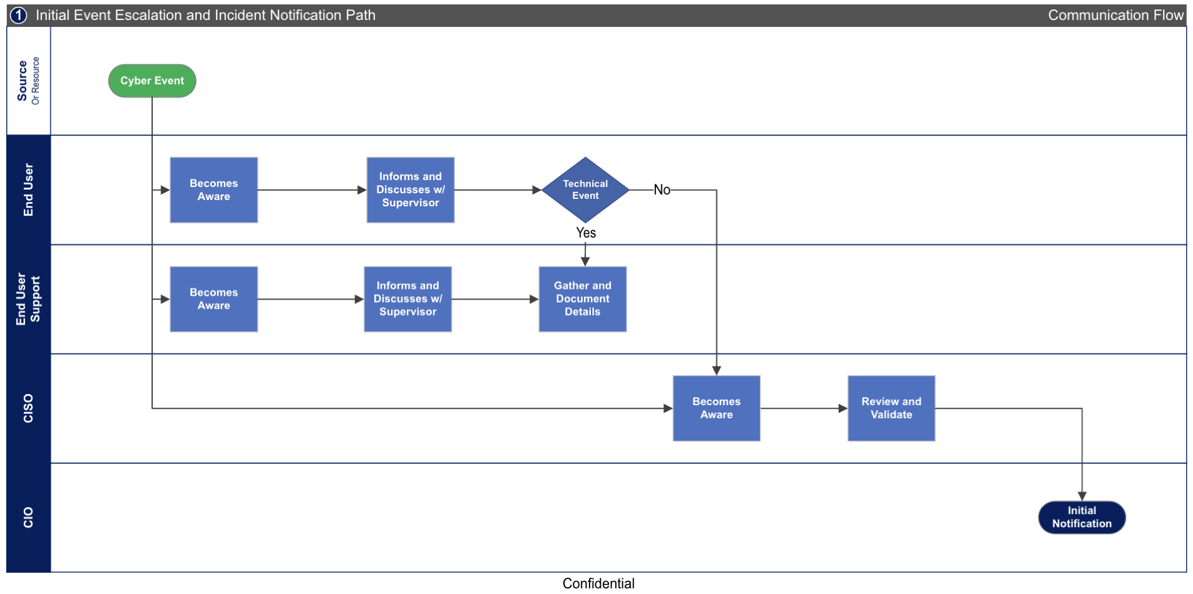

Figure 2
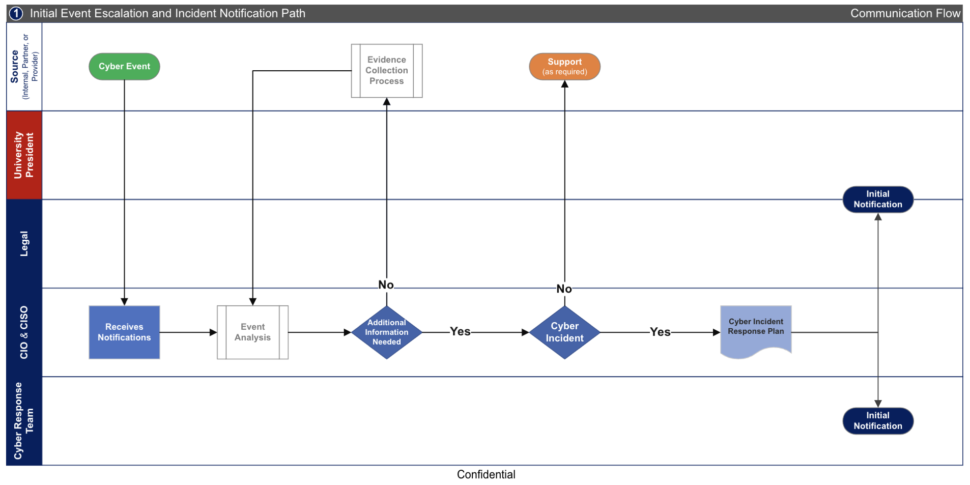
  - Initial Security Event Classification Process and Cyber Incident Response Plan Initiation
Louisiana State Police Cyber Crime Unit / Louisiana Cyber Investigators’ Alliance: CIRM to call CCU for evidence collection and analysis.

Louisiana Emergency Support Function -17: CIRM to confer with ESF-17 co-leads for personnel assignments to assist CIRM and CIRT with Phases 3 and 4.

Figure 3
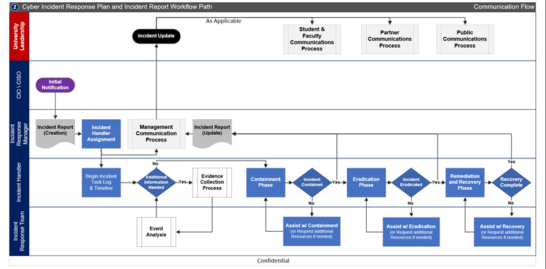
  - Cyber Incident Response Plan and Incident Report Workflow Path
Louisiana State Police Cyber Crime Unit / Louisiana Cyber Investigators’ Alliance: CIRM to call CCU for evidence collection and analysis.

Louisiana Emergency Support Function -17: CIRM to confer with ESF-17 co-leads for personnel assignments to assist CIRM and CIRT with Phases 3 and 4.

Louisiana State Police Cyber Crime Unit | Evidence Collection and Analysis Process

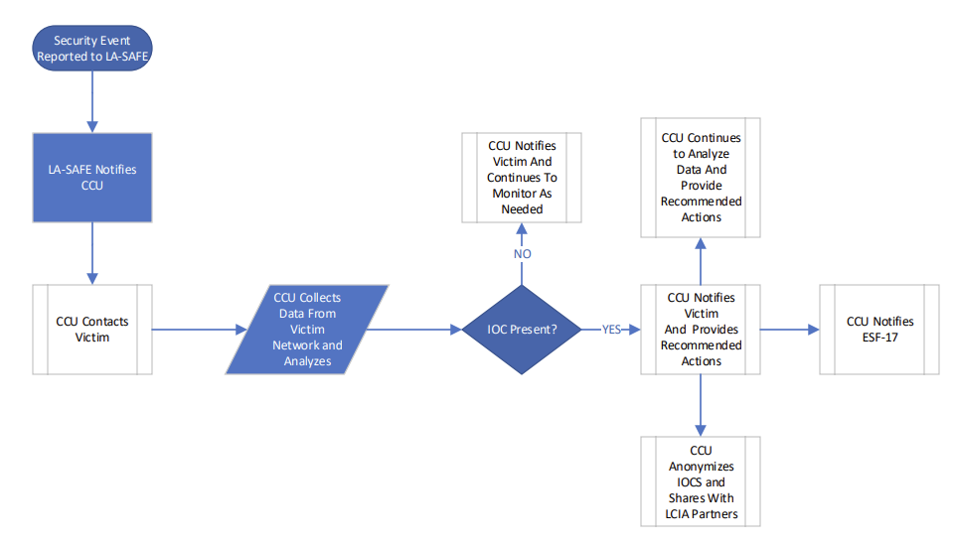

WebEOC Initiation Instructions and Process
A WebEOC request, detailed further on the GOHSEP website, is a secure, Internet-based emergency information management application that provides real-time information sharing of operational details from various government and public safety groups in response to an imminent threat, emergency or disaster. ESF-17 utilizes WebEOC requests to keep Executive Branch Agency directors updated on resource deployment and identify potential compounding crisis factors.

WebEOC requests must be initiated through the Parish Office of Emergency Preparedness and GOHSEP. Parish Offices of Emergency Preparedness are listed below:
Parish | Director | Voice | Fax | Social |  | Website
Acadia | Ashley LeBlanc  email: acadiaohsep@appj.org | (337) 783-4357 |  |  |  | www.appj.org
Allen | Chris Oakes  email: coakes@allenparishso.com | (337) 639-3091 |  |  |  | http://allenparishso.org/
Ascension | Rachael Wilkinson  email: rwilkinson@apgov.us | (225) 621-8360 | (225) 644-3039 |  |  | http://ascensionparish.net/
Assumption | John Boudreaux  email: johnboudreaux@assumptionoep.com | (985) 369-7386 |  |  |  | http://www.assumptionla.com/153/Office-of-Emergency-Preparedness
Avoyelles | Joey Frank  email: aohsep@avoypj.org | (318) 240-9160 | (318) 240-9162
Beauregard | Scott Greenmun  email: bpso434@yahoo.com | (337) 460-5447 | (337) 396-8642 |  |  | http://beauparish.org/
Bienville | Rodney Warren  email: rwarren@bienvilleparish.org | (318) 263-2019 | (318) 263-7404 |  |  | http://bienvilleparish.org/
Bossier | Ian Snellgrove  email: isnellgrove@bohsep.org | (318) 425-5352 |  |  |  | http://www.bossierparishla.gov/index.aspx
Caddo | Robert Jump  email: Robert.Jump@caddosheriff.org | (318) 675-2255 | (318) 675-2268 |  |  | http://caddosheriff.org/
Calcasieu | Richard "Dick" Gremillion  email: dgremillion@cppj.net | (337) 721-3800 | (337) 437-3583 |  |  | http://cppj.net/
Caldwell | Freddy Mercer  email: caldwellohsep@bellsouth.net | (318) 331-1713 | (318) 649-3765
Cameron | Danny Lavergne  email: oep@cameronpj.org | (337) 775-7048 | (337) 775-7043 |  |  | https://cameronpj.org/
Catahoula | Ellis Boothe  email: catahoulaohsep@att.net | (318) 744-5697 | (318) 744-5205
Claiborne | Dennis Butcher  email: claiborne.oep@claiborneparish.org | (318) 927-9118 | (318) 927-2115 |  |  | http://claiborneparish.org/
Concordia | Tim Vanier  email: oep@conppj.org | (318) 414-1768 |  |  |  | http://www.conppj.org/
DeSoto | Hannah Hucakabay  email: sheriff@dpso.org  Todd Edwards, OHSEP Administrator  email: oep@dpso.org | (318) 872-3956  (318) 872-1877 | (318) 872-2304 |  |  | http://www.dpso.org/
East Baton Rouge | Clay Rives  email: crives@brgov.com | (225) 389-2100 | (225) 389-2114 |  |  | https://www.brla.gov/412/Mayors-Office-of-Homeland-Sec-Emergency-
East Carroll | Kenneth Baker  email: ecpjoep@bayou.com | (318) 559-2256 | (318) 559-1502
East Feliciana | Joseph Moreau  email: efeoc@outlook.com | (225) 719-1962  (225) 244-5881 | (225) 683-1478
Evangeline | Liz Hill  email: vangy911@epcd911.org | (337) 363-3267 | (337) 363-3308
Franklin | Todd Roberts  email: toddroberts@franklinsheriff.net | (318) 341-3739 | (318) 341-3740
Grant | Cade Fletcher  email: fletcher@grantso.org | (318) 627-3261 | (318) 627-5927 |  |  | http://www.grantso.org/
Iberia | Prescott Marshall  email: pmarshall@iberiagov.net | (337) 369-4427 | (337) 369-9956 |  |  | http://iberiaparishgovernment.com/
Iberville | Clint Moore  email: cmoore@ibervilleparish.com | (225) 687-5140 | (225) 687-5146 |  |  | http://ibervilleparish.com/
Jackson | Brent D. Barnett  email: bbarnett@jacksonparishsheriff.com | (318) 259-9021 |  |  |  | http://www.jacksonparishsheriff.com/
Jefferson | Joseph Valiente  email: jvaliente@jeffparish.net | (504) 349-5360 | (504) 227-1315 |  |  | http://jeffparish.net/
Jefferson Davis | Marcus Peterson  email: jeffdavisparishoep60@gmail.com | (337) 246-5588 |  |  |  | http://www.jeffdavis.org/
Lafayette | Craig Stansbury  email: eoc@lafayettela.gov | (337) 291-5075 | (337) 291-5080 |  |  | http://lafayetteohsep.org/
Lafourche | Chris Boudreaux  email: BoudreauxCL@lafourchegov.org | (985) 537-7603 |  |  |  | http://lafourchegov.org/
LaSalle | Dana Chapman  email: dchapman@lasalleso.com | (318) 992-0673 | (318) 992-8919
Lincoln | Kip Franklin  email: kfranklin@lincolnparish.org | (318) 251-6454 | (318) 513-6209
Livingston | Shannon Dyer  email: lohsep1@lpgov.com | (225) 686-3985 | (225) 686-7280 |  |  | http://www.livingstonparishla.gov/
Madison | Jane Sanders  email: janeriggssanders@gmail.com | (318) 235-3134
Morehouse | James Mardis  email: jmardis@mpso.net | (318) 239-8062 | (318) 281-1773 |  |  | http://mpso.net/
Natchitoches | Mary Jones  email: mjones@npsheriff.net | (318) 238-7720 | (318) 357-2208 |  |  | http://npsheriff.org/
Orleans | Collin Arnold  email: cmarnold@nola.gov | (504) 658-8700 | (504) 658-8729 |  |  | http://www.nola.gov/ready/
Ouachita | Neal Brown  email: anbrown@ohsep.net | (318) 322-2641 | (318) 322-7356 |  |  | http://oppj.org/
Plaquemines | Patrick Harvey  email: pharvey@ppgov.net | (504) 297-2477 | (504) 297-5635 |  |  | http://plaqueminesparish.com/
Pointe Coupee | Mark Ward  email: mward@pcparish.org | (225) 638-9556 | (225) 694-5408 |  |  | http://www.pcpso.org/
Rapides | Sonya Wiley-Gremillion  email: swiley@rapides911.org;  rapides911oep@suddenlinkmail.com | (318) 445-5141 | (318) 445-5605 |  |  | http://rppj.com/
Red River | Shane Hubbard  email: redriver.ohsep@gmail.com | (318) 932-8502 | (318) 932-8502 |  |  | http://redriverready.com/
Richland | Dawn Williams  email: dwilliams@richlandso.org | (318) 728-2063 | (318) 728-3851
Sabine | David Davis  email: spoep@cp-tel.net | (318) 256-2675 | (318) 256-9652 |  |  | http://sabineparishpolicejury.com/
St. Bernard | John Rahaim  email: jrahaim@sbpg.net | (504) 278-4268 |  |  |  | http://www.sbpg.net/
St. Charles | Jason Tastet  email: jtastet@stcharlesgov.net | (985) 783-5050 | (985) 783-6375 |  |  | http://stcharlesparish-la.gov/
St. Helena | Roderick Matthews  email: rmatthews@sthelenaparish.la.gov | (225) 222-3544 | (225) 222-3696 |  |  | http://sthelenaparish.la.gov/
St. James | Eric Deroche  email: eric.deroche@stjamesla.com | (225) 562-2346 | (225) 562-2269 |  |  | http://www.stjamesla.com/
St. John the Baptist | Travis Perrilloux  email: Travis.Perrilloux@stjohn-la.gov | (985) 652-2222 | (985) 652-2183 |  |  | http://www.sjbparish.com/
St. Landry | Van Reed  email: vreed@slpgov.net | (337) 351-2467 | (337) 948-1281 |  |  | http://stlandryparish.org/
St. Martin | Terry Guidry  email: teguidry@smpso.org | (337) 394-2812 | (337) 332-0492 |  |  | http://www.stmartinohsep.org/
St. Mary | David Naquin  email: dnaquin@stmaryparishla.gov | (337) 828-4100 ext. 135 | (337) 828-4092 |  |  | http://stmaryohsep.org/
St. Tammany | Clarence Powe  email: cpowe@stpgov.org | (985) 898-2359 | (985) 898-3030 |  |  | http://stpgov.org/
Tangipahoa | Dawson Primes  email: dawson.primes@tangipahoa.org | (985) 748-3211 | (985) 748-7050 |  |  | http://www.tangisafe.com/
Tensas | William "Rick" Foster  email: tensasoep@gmail.com | (318) 766-3992 | (318) 766-4391
Terrebonne | Earl J. Eues  email: eeues@tpcg.org | (985) 873-6357 | (985) 850-4643 |  |  | http://tpcg.org/
Union | Shannon Futch  email: sfutch@upohsep.net | (318) 558-1586 |  |  |  | https://upohsep.net/
Vermilion | Homer Stelly  email: vpoep@yahoo.com | (337) 898-4308 | (337) 898-4309 |  |  | http://vppj.org/
Vernon | Kenneth Moore  email: kmoore@vernonso.org | (337) 238-0815 | (337) 238-9025 |  |  | http://vernonso.org/
Washington | Barbara Jo Breland  email: bjbreland@wpgov.org | (985) 839-0434 | (985) 839-0435 |  |  | http://www.washingtonparishalerts.org/
Webster | Brian Williams  email: Webster.ohsep@gmail.com | (318) 371-1128 | (318) 371-1788 |  |  | http://www.websterparishla.org/index.html
West Baton Rouge | Deano Moran  email: deano.moran@wbrcouncil.org | (225) 346-1577 | (225) 346-0284 |  |  | http://wbrcouncil.org/
West Carroll | Myrtle Green  email: directorwcpoep@yahoo.com | (318) 428-8020 | (318) 428-8025
West Feliciana | Brian Spillman  email: bspillman@wfpso.org | (225) 784-3136 | (225) 635-6996 |  |  | http://www.wfpso.org/
Winn | Cranford Jordan, Sheriff/OEP  email: sheriff@winnsheriff.org / winnohsep@winnparish.org | (318) 628-4611 | (318) 727-3112 |  |  | http://winnparish.org/

GLOSSARY

Definitions:
All definitions contained in the State of Louisiana’s Information Security Policy are incorporated by reference, in addition to the following:

Asset Owner: the individual or entity who is tasked with responsibility for the portion(s) of the System affected by Cyber Incident or Security Event.

Cyber Incident: An attempted, suspected, or successful unauthorized access, use, disclosure, modification, or destruction of data; interference with information technology operations; or a violation of any End User Agreement. This is the definition of “Incident” in the State of Louisiana Information Security Policy.

Acronyms:
The following acronyms are used in this document:

CIMRP: Cyber Incident Management and Response Report | EOP: Parish Emergency Operation Centers
CIO: Chief Information Officer | ESF-17: State of Louisiana Emergency Support Function – 17 (Cyber Incident Management and Response)
CIRM: Cyber Incident Response Manager | FBI: Federal Bureau of Investigation
CIRP: Cyber Incident Response Plan | FTI: Federal Tax Information
CIRR: Cyber Incident Response Report | GOHSEP: State of Louisiana Governor’s Office of Homeland Security and Emergency Preparedness
CIRT: Cyber Incident Response Team | HR: Human Resources
CISA: Cybersecurity and Infrastructure Security Agent | IDS: Intrusion Detection System
CISO: Chief Information Security Officer | LSP: Louisiana State Police
CLO: Chief Legal Officer | OTS: Office of Technology Services
COO: Chief Operations Officer  COOP: Continuity of Operations Plan | PCI DSS: Payment Card Industry Data Security Standard
CSG: Cyber Steering Group | TIGTA: Treasury Inspector General for Tax Administration
EDR: Endpoint Detection and Response | USSS: United States Secret Service

